**Executive Summary**

The main aim of this report is to pinpoint issues or potential issues regarding Human Resource Mangement within pharmaceutical company Totally Fake Company, TFC in order to aid in enhancing business operations. This is achieved through analysis of employee data. Analysis concentrates on the impact of training frequency and relationship satisfaction on job satisfaction, also, how job involvement influences performance. The results reflected problems in training effectiveness, unsuitable job motivators and lack of wellbeing which lowered job satisfaction and performance. Brief recommendations include conducting a needs assessment to redesign training programs, develop alternative intrinsic motivators, e.g., nature of work and amend organization policies to omit harsh punishments.

**Introduction**

The main aim of human resource management is increasing and maintaining employee performance to generate success for the organization (Verburg 2015). These processes have now been combined with technology and data analysis to improve on effectiveness (Nasar et al. 2020). Similarly, this report aims to demonstrate data analysis in human resources through these questions:

*1.How does annual frequency of training impact employees’ job satisfaction as per their job level?*

*2.How does the factor relationship satisfaction impact each department’s overall job satisfaction?*

*3.How is performance influenced by job involvement taking into consideration each job level?*

Questions cater to job satisfaction and performance as they are seen as key predictors for organizational success (Culibrk et al. 2018). Hence, identifying potential problems limiting TFC’s satisfaction and performance is crucial to enhance organizational operation effectiveness. These problems will also be corroborated by practical recommendations.

**Analysis and explanation**

According to the data dictionary, relationship satisfaction is rated from 1-4. Therefore, it will be presumed that all variables of satisfaction (job, relationship, environment) are similarly rated. Because this is an even scale, there is no neutral attitude, 1-2 represents an unsatisfied attitude and 3-4 represents a satisfied attitude.

*Question 1*

Organization training has been widely accepted as an effective method to increase employee satisfaction and retain productivity by both employees and employers (Georgellis and Lange 2007). However, organizations must evaluate their training programs to ensure they meet employees’ and organizational needs (Alvarez et al. 2004).

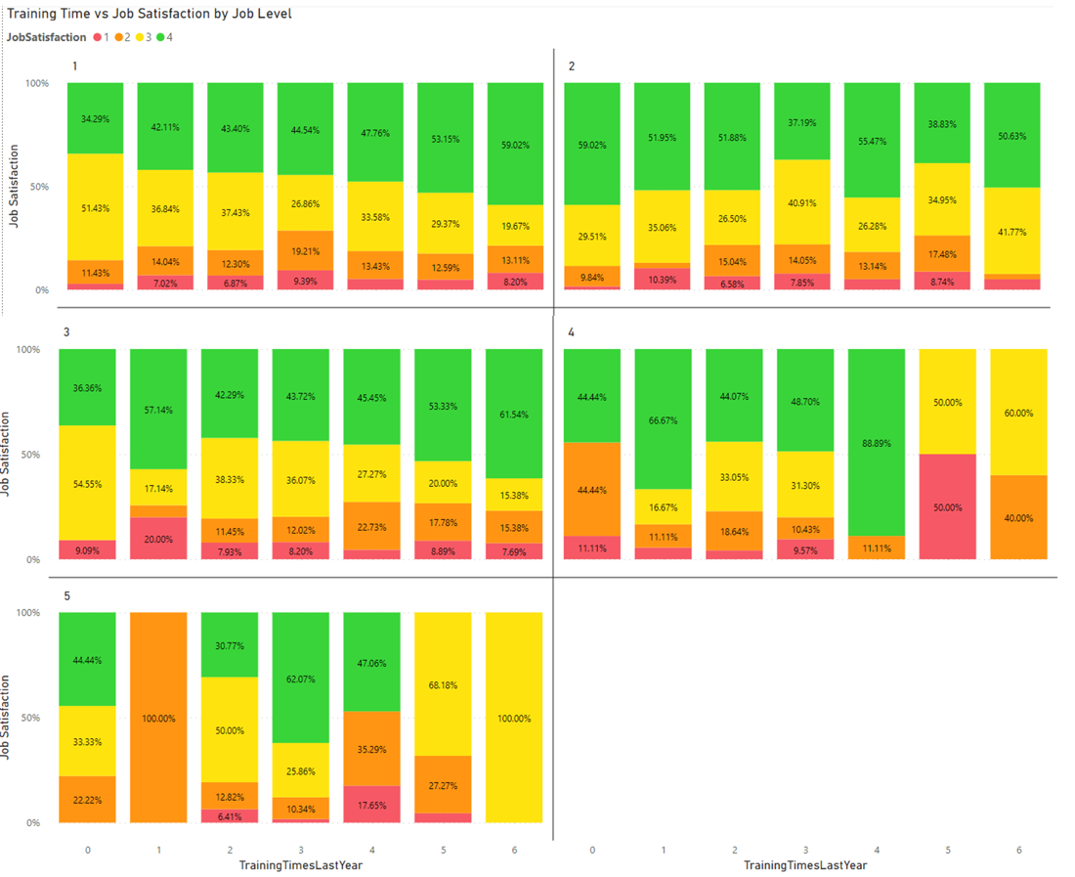

Figure 1. Percentage bar chart of job satisfaction count in relation to annual training frequency, divided into 5 job levels.

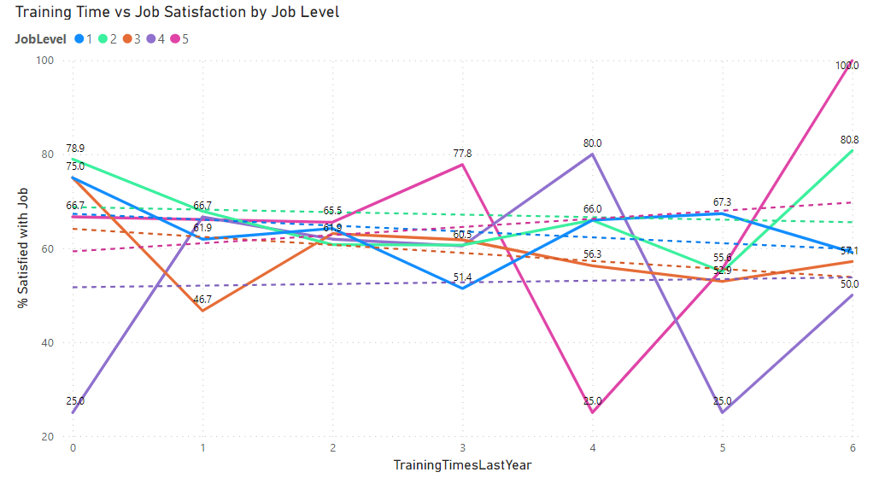

Figure 2. Line chart depicting percentage of employees satisfied with job in relation to annual training frequency, divided into 5 job levels.

There are 5 job levels with larger numbers meaning higher positions; level 4 and 5 refer to managers, as stated by their job roles. Training frequency ranges from 1-6 times per year, because this is a relatively low number, it is assumed to be formal classroom training.

Figure 1 acts as an overview that expresses the general proportions of job satisfaction. Because there is no neutral response, the data will be simplified from figure 1 into satisfied percentages through figure 2. Whether there is a positive or negative correlation will be decided by the trend line. Referring to figure 2, lower job levels from 1-3 have decreased job satisfaction with increasing training frequency. Contrastingly, levels 4-5 have increased job satisfaction.

Personal development is a distinct motivation that can be linked to job satisfaction (Hanaysha and Tahir 2016). For this reason, if training is ineffective, employees may find it unnecessary and disruptive and decrease job satisfaction. Training can be seen as ineffective if the post-training environment is not favorable toward the application of new skills acquired from training (Arthur et al. 2003). Additionally, the method of delivery, the type of skill requiring training as well as their compatibility also contribute to training effectiveness (Arthur et al. 2003). This is corroborated as formal training is considered inadequate, contributing to only less than 10% of employee training despite being the main form of training (Eddy et al. 2006). Different job levels require different skills. Based on these findings, it can be assumed that managerial skills more involved with interpersonal and conceptual skills have lower trainability in accordance with TFC’s chosen delivery method. Another possibility is that the skills being trained are irrelevant to the job.

*Question 2*

Study shows that employees with lower communication satisfaction are more likely to quit (Ozer et al. 2017). Accordingly, relationship satisfaction is also seen as a job motivation. However, this general consensus may not apply to all organizations.

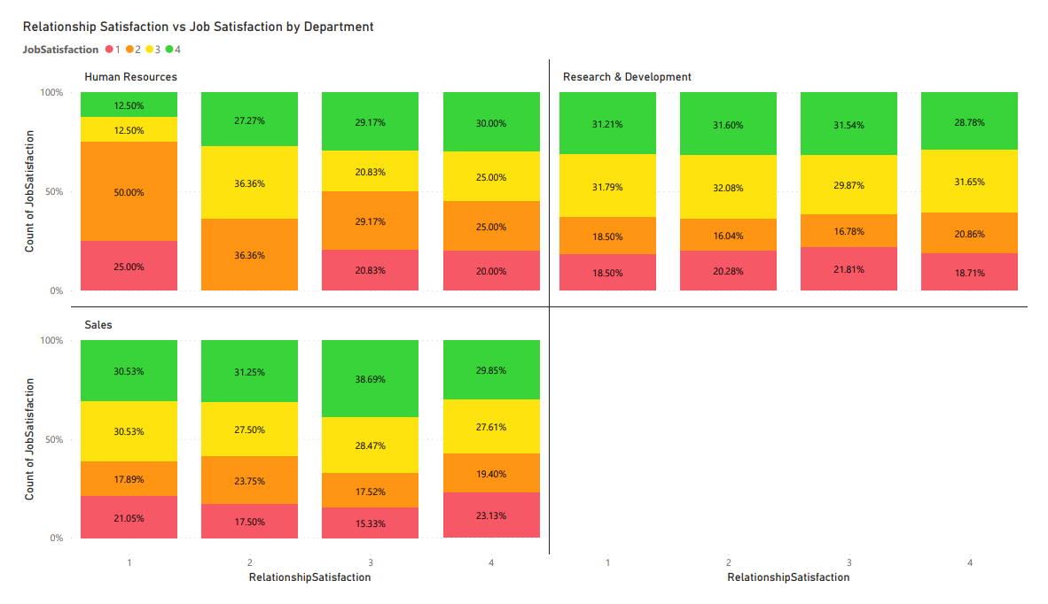

Figure 3. Percentage bar chart demonstrating relationship satisfaction count in relation to job satisfaction by individual departments.

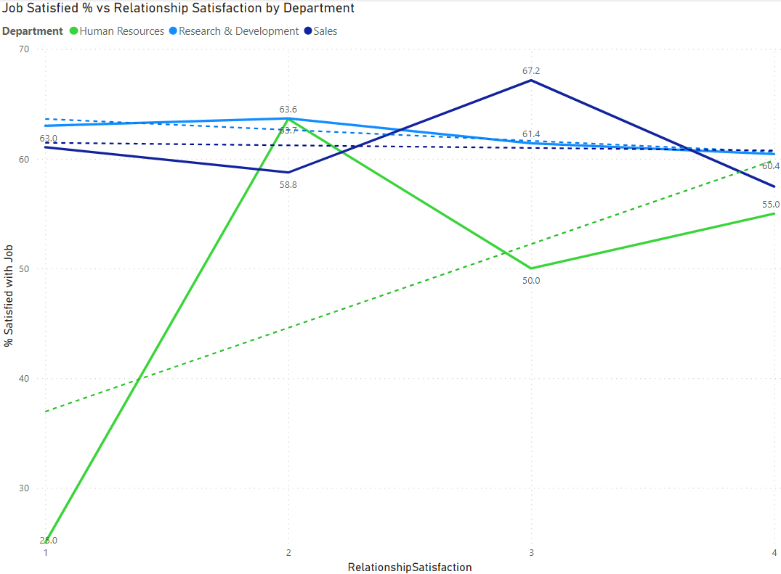

Figure 4. Line chart demonstrating percentage of employees satisfied with job in relation to relationship satisfaction by individual departments.

This analysis is divided into three departments, Human Resources, Research and Development, and Sales. Figure 3 provides an overview of job satisfaction proportions while figure 4 shows fluctuations in job satisfaction percentage in relation to relationship satisfaction to further the analysis. There is a clear positive correlation for the Human Resources department with a gradual increase in job satisfaction percentage as relationship satisfaction increases. Contrarily, for Sales and Research and Development, job satisfaction percentage decreases. Based on the slope of the trend lines, it can be concluded that the correlation is noticeably weak for Sales and Research and Development.

Findings indicate some negative correlations contradicting previous research, despite that, harbors implications for TFC. Satisfaction is a subjective measure of a job’s abilities to meet one’s personal expectations (Mishra 2013). Therefore, satisfaction rating not only depends on work conditions but also employees’ pre-existing expectations. The Human Resources department is shown to be more efficient when focused on relationships due to the nature of the job requiring extensive cooperation (Ingham and Ulrich 2016). In combination, the ability to perform one’s job well and generate success is also a factor defining job satisfaction (Aziri 2011). Hence, it can be presumed that good work relationships contribute more to overall job satisfaction for Human Resource personnel. Job satisfaction is affected by a multitude of other factors, examples include salary, supervision and work requirements (Fu et al. 2011). Therefore, employees from Sales and Research and Development may have stronger demands for motivators other than relationship satisfaction; the job factor does not match their expectations as they are influenced by differences in work structure.

*Question 3*

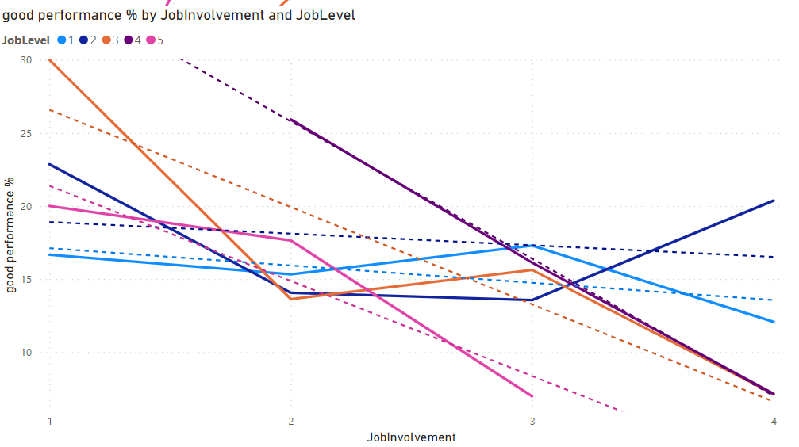

Figure 5. Line chart depicting percentage of employees with max performance rating in relation to their job involvement rating, divided by job level.

Performance rating is rated on a scale of 1-4. Surprisingly, there exists only values 3-4; this suggests that TFC only consists of employees with satisfactory and above satisfactory performance. A possible explanation for this could be that TFC has strict performance policies to terminate employees that do not meet the standard in order to ensure performance.

Data shows that the percentage of employees with performance above satisfactory, I.e., 4, decreases with increasing job involvement for all job levels. This is again determined by their specific trend line. Furthermore, the correlation is weaker for job levels 1 and 2, expressing that their performance is not as impacted by job involvement compared to higher job levels.

Job involvement can be defined as the extent to which (1) employees prioritize work emotionally or (2) they are psychologically impacted by work performance (Lodahl et al. 1965). To be precise, it is theorized that good performance enhances self-esteem (Rabinowitz et al. 1977). Job involvement can also be seen as a positive indicator of performance (Probst 2000). Despite that, it is argued that whether involvement is a positive indicator depends on how it was measured (Rotenberry and Moberg 2007). Accordingly, findings of a negative relationship between these two variables suggest that this job involvement measure is not limited to voluntary commitment but also role-required tasks. In combination with the previous assumption that TFC practices strict performance regulating policies, it is possible that high involvement could be caused by fear and stress for severe professional consequences. Consequently, employees that are more involved experience greater unfavorable psychological impacts when faced with job insecurities (Greenhalgh and Rosenblat 1984). Moreover, a positive state of mental well-being can be a decisive factor in predicting performance (Wright and Cropanzano 2000). With that established, TFC is facing a crucial problem in that their method of boosting performance is in fact causing worse performance.

**Practical implications**

*Increasing training effectiveness*

TFC needs to increase the effectiveness of training programs dedicated to managerial job levels to boost job satisfaction. Cekada (2011) stated that needs assessment is essential in producing an effective training program. It provides organizations with relevant information on what skills or qualifications are lacking or desired by employees (Arthur et al. 2003). Therefore, the skills developed will match organization needs, ensuring its post-training practicality. As TFC only needs to modify training programs for managers, the number requiring training is not as vast. Thus, TFC can consider more costly approaches. For instance, one-on-one mentoring has proven to be effective due to its ability to provide psychological support (Martin et al. 2014). Programmed or technology-based training has the main advantage of high flexibility (Martin et al. 2014). This can benefit managers who face heavy workloads and require more flexibility in time management.

*Employing job factors other than relationship satisfaction as motivation*

Since employees from Sales and Research and Development do not benefit from high relationship satisfaction, TFC should consider alternative methods of intrinsic motivation to boost job satisfaction for these two departments while limiting relationship-building activities. This is because Tietjen and Myers (1998) suggest that intrinsic fulfillment gained from work tasks is the strongest job factor influencing satisfaction. Consequently, tasks should provide employees with a sense of achievement and should not be monotonous and repetitive. However, information on employees’ specific complaints is required to develop a detailed plan to improve motivation (Echemnu and Manalastas 2013). Some general ideas include clear communication in facilitating tasks, distinct policies and fairness or high job autonomy and flexibility (Echemnu and Manalastas 2013; Lobel et al. 2020). On the other hand, TFC should continue to focus on building relationships within the Human Resources department following current methods, as it already yields beneficial results.

*Improving mental wellbeing*

While job involvement was negatively affecting performance, the goal is to resolve the hidden issue rather than reducing involvement. It is theorized that TFC employees are facing high levels of stress and fear due to strict policies that also lead to job insecurity. Thereby, the main resolution is to abolish or amend policies that threaten job security. More specifically, the organization should adopt a more supportive attitude and encourage improvement before turning to termination. This is corroborated by research suggesting that the link between punishment and performance is weak (McNamara et al. 2022). In a general sense, TFC’s management procedures should limit its reliance on punishment. Simple changes in workflow, for instance, work breaks, are also efficient in reducing strain upon employees (Lyubykh et al. 2022). Additionally, mentioned methods to increase intrinsic motivation, thus, satisfaction, can also contribute to improving employees’ mental state.

**Conclusion**

Based on the questions, issues were identified regarding training effectiveness on managerial levels, inefficient job motivators for Sales and Research and Development departments and overall poor mental wellbeing, together, negatively affecting job satisfaction and performance. Recommendations include improving training effectiveness through a needs assessment and redesign of their manager training program to fit specific organization needs. Intrinsic job factors, e.g., nature of work tasks, should be enhanced after surveying specific employee complaints to boost job satisfaction. Lastly, TFC should cease the use of strict punishment to decrease stress that can interfere with performance.

**References**

Alvarez K, Salas E and Garofano C (2004) 'An Integrated Model of Training Evaluation and Effectiveness', *Human Resource Development Review*, 3(4):299-444.

Arthur W, Bennett W, Edens S and Bell T (2003) 'Effectiveness of training in organizations: A meta-analysis of design and evaluation features', *Journal of Applied Psychology*, 88(2):234-245.

Aziri B (2011) 'Job Satisfaction: A Literature Review', *Management Research and Practice*, 3(4):77-86.

Cekada L (2011) 'Need training? Conducting an Effective Needs Assessment', *Professional Safety*, 56(12):28-34.

Culibrk J, Delic M, Mitrovic S and Culibrk D (2018) 'Job Satisfaction, Organizational Commitment and Job Involvement: The Mediating Role of Job Involvement', *Frontiers in Psychology*, 9(132):1-12.

Echemnu O and Manalastas Z (2013) 'Job characteristics and job satisfaction: Basis for enhanced intrinsic job motivation program of employees in some catholic institutions in the philippines', *International Journal of Education & Management*, 3(1):57-61.

Eddy E, D'Abate C, Tannenbaum S, Skeaton S and Robinson G (2006) 'Key characteristics of effective and ineffective developmental interactions', *Human Resource Development Quarterly*, 17(1):1-129, 10.1002/hrdq.1161.

Fu W, Deshpande S and Zhao X (2011) 'The Impact of Ethical Behavior and Facets of Job Satisfaction on Organizational Commitment of Chinese Employees', *Journal of Business Ethics*, 104(1):537-543, 10.1007/s10551-011-0928-4.

Georgellis Y and Lange T (2007) 'Participation in continuous, on-the-job training and the impact on job satisfaction: longitudinal evidence from the German labour market', *The International Journal of Human Resource Management*, 18(6):969-985.

Greenhalgh L and Rosenblatt Z (1984) 'Job insecurity: Toward conceptual clarity', *The Academy of Management Review*, 9(3):438-448, 10.2307/258284.

Hanaysha J and Tahir P (2016) 'Examining the Effects of Employee Empowerment, Teamwork, and Employee Training on Job Satisfaction', *Procedia - Social and Behavioral Sciences*, 219(1):272-282, 10.1016/j.sbspro.2016.05.016.

Ingham J and Ulrich D (2016) 'Building better HR departments', *Stategic HR Review*, 15(3):129-136.

Lobel T, Ho H and Baker J (2021) 'When supportive workplaces positively help work performance', *Baltic Journal of Management*, 16(2):208-227, 10.1108/BJM-06-2020-0220.

Lodahl T and Kejner M (1965) 'The definition and measurement of job involvement', *Journal of Applied Psychology*, 49(1):24-33, 10.1037/h0021692.

Lyubykh Z, Gulseren D, Premji Z, Wingate T and Deng C (2022) 'Role of work breaks in well-being and performance: A systematic review and future research agenda', *Journal of Occupational Health Psychology*, 27(5):470-487, 10.1037/ocp0000337.

Martin B, Kolomitro K and Lam T (2014) 'Training Methods: A Review and Analysis', *Human Resource Development Review*, 13(1):11-35, 10.1177/1534484313497947.

McNamara T, Meloso D, Michelotti M and Michelloti P (2022) '‘You are free to choose . . . are you?’ Organisational punishment as a productivity incentive in the social science literature', *Human Relations*, 75(2):213-407, 10.1177/00187267211007891.

Mishra P (2013) 'Job Satisfaction', *Journal Of Humanities And Social Science*, 14(5):45-54.

Nasar N, Ray S, Umer S and Pandey H (2020) 'Design and data analytics of electronic human resource management activities through Internet of Things in an organization', *Journal of Software: Practice and Experience*, 51(12):2411-2427.

Ozer O, Santas F, Santas G and Sahin D (2017) 'Impact of nurses' perceptions of work environment and communication satisfaction on their intention to quit', *International Journal of Nursing*, 23(6):1-8, 10.1111/ijn.12596.

Probst T (2000) 'Wedded to the job: Moderating effects of job involvement on the consequences of job insecurity', *Journal of Occupational Health Psychology*, 5(1):63-73, 10.1037/1076-8998.5.1.63.

Rabinowitz S and Hall D (1977) 'Organizational research on job involvement', *Psychological Bulletin*, 84(2):265-288, 10.1037/0033-2909.84.2.265.

Rotenberry P and Moberg P (2007) 'Assessing the impact of job involvement on performance', *Management Research News*, 30(3):203-215, 10.1108/01409170710733278.

Tietjen M and Myers R (1998) 'Motivation and job satisfaction', *Management Decision*, 36(4):226-231, 10.1108/00251749810211027.

Verburg R (2015) 'Human Resource Management', *Wiley Encyclopedia of Management*, 6(1):1-6, 10.1002/9781118785317.weom060104.

Wright A and Cropanzano R (2000) 'Psychological well-being and job satisfaction as predictors of job performance', *Journal of Occupational Health Psychology*, 5(1):84-94, 10.1037/1076-8998.5.1.84.